Q1) Euclid’s algorithm for GCD

#include<stdio.h>

void main() {
int a, b, m, n, r, modcount = 0, assigncount = 0;

printf("Key in the two numbers [first number should be greater than second number] whose GCD is to be calculated\n");

scanf("%d %d", &a, &b);
m = a;
n = b;

while (n > 0) {
r = m % n;
modcount++;
m = n;
n = r;
assigncount = assigncount + 2;
}

printf("\n\tGCD of %d and %d is %d.\n\tThe mod function was called %d time[s].\n\tAssignment operation was done %d times.\n",
a, b, m, modcount, assigncount);
}

Output:
Compiled using online C compiler
(https://www.programiz.com/c-programming/online-compiler)

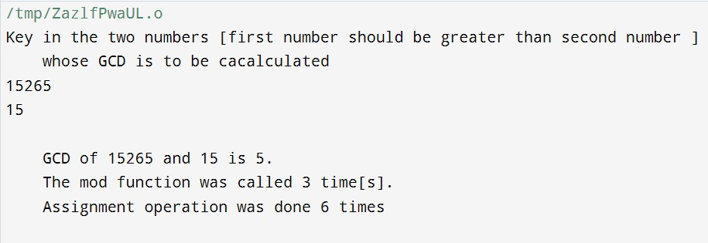

Q2) Comparison of Horner’s rule and brute force method

#include<stdio.h>

void main() {
int P, x, degree, coeff[10], i, loopmultaddcount = 0;
int p[10], k, pbrute = 0, brutemultcount = 0;

printf("Key in the degree of polynomial\n");
scanf("%d", &degree);

printf("Key in the %d coefficients starting from that for degree %d\n", degree + 1, degree);
for (i = 0; i <= degree; i++) {
scanf("%d", &coeff[i]);
}

printf("The coefficients are\n");
for (i = 0; i <= degree; i++) {
printf("%d\t", coeff[i]);
}
printf("\n");

printf("Key in the value for X\n");
scanf("%d", &x);

// Horner's method
P = coeff[0];
for (i = 1; i <= degree; i++) {
P = P * x + coeff[i];
loopmultaddcount++;
}

// Brute force method
for (k = 0; k <= degree; k++) {
p[k] = coeff[k];
for (i = 1; i <= degree - k; i++) {
p[k] = p[k] * x;
brutemultcount++;
}
}

for (i = 0; i <= degree; i++) {
pbrute = pbrute + p[i];
}

printf("\n\tP(x) at x= %d is P(%d)=%d.\n\tIn the Horner's method:\n\t\t[1] The loop was iterated %d time[s].\n\t\t[2] There were %d multiplication operations.\n\t\t[3] There were %d addition operations.\n",
x, x, P, loopmultaddcount, loopmultaddcount, loopmultaddcount);

printf("\n\tIn the brute force method:\n\t\t[1] P(x) at x= %d is P(%d)=%d.\n\t\t[2] There were %d multiplications as against %d in the Horner's method.\n\n",
x, x, pbrute, brutemultcount, loopmultaddcount);
}

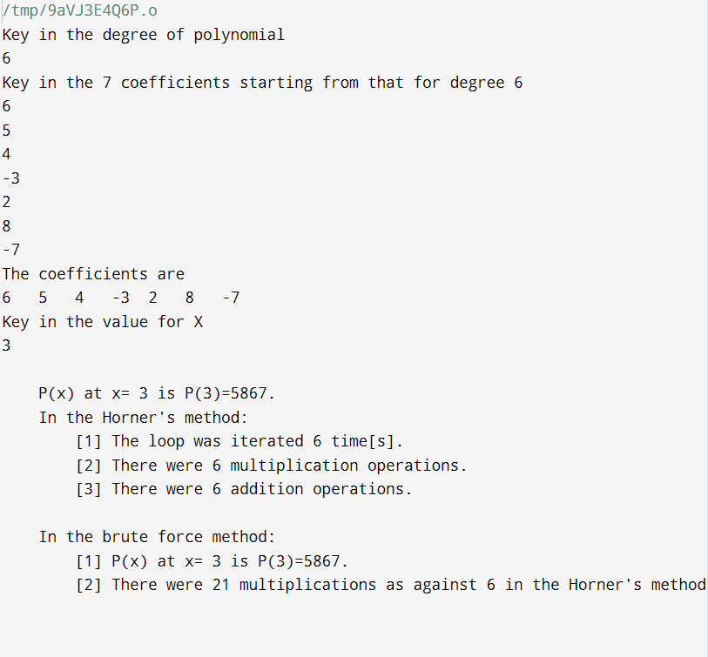

Q3) Matrix Multiplication

#include <stdio.h>
#include <stdlib.h>

void main() {
int A[10][10], B[10][10], C[10][10];
int rA, cA, rB, cB;
int i, j, k;
int outerloopcount = 0, middleloopcount = 0, innerloopcount = 0, addncount = 0, multcount = 0;

printf("Key in the row size and column size [maximum is 10 X 10] for the first matrix, say, A\n");
scanf("%d %d", &rA, &cA);

printf("Key in the row size and column size [maximum is 10 X 10] for the second matrix, say, B\n");
scanf("%d %d", &rB, &cB);

if (cA != rB) {
printf("\nMatrices are incompatible for multiplication\n");
exit(0);
}

printf("Key in row-wise the elements of the first [%d X %d] matrix A\n", rA, cA);
for (i = 0; i < rA; i++)
for (j = 0; j < cA; j++)
scanf("%d", &A[i][j]);

printf("\nFirst matrix A is:\n");
for (i = 0; i < rA; i++) {
for (j = 0; j < cA; j++)
printf("\t%d\t", A[i][j]);
printf("\n");
}
printf("\nKey in row-wise the elements of the second [%d X %d] matrix B\n", rB, cB);
for (i = 0; i < rB; i++)
for (j = 0; j < cB; j++)
scanf("%d", &B[i][j]);

printf("\nSecond matrix B is:\n");
for (i = 0; i < rB; i++) {
for (j = 0; j < cB; j++)
printf("\t%d\t", B[i][j]);
printf("\n");
}
for (i = 0; i < rA; i++) {
outerloopcount++;
for (j = 0; j < cB; j++) {
middleloopcount++;
C[i][j] = 0;
for (k = 0; k < cA; k++) {
innerloopcount++;
C[i][j] += A[i][k] * B[k][j];

addncount++;
multcount++;
}
}
}

printf("\nThe matrix product is C = A X B and C is:\n");
for (i = 0; i < rA; i++) {
for (j = 0; j < cB; j++)
printf("\t%d\t", C[i][j]);
printf("\n");
}
printf("\nStatistics:\n");
printf("[1] Outer loop was iterated for %d time(s).\n", outerloopcount);
printf("[2] Middle loop was iterated for %d time(s).\n", middleloopcount);
printf("[3] Inner loop was iterated for %d time(s).\n", innerloopcount);
printf("[4] %d additions were done.\n", addncount);
printf("[5] %d multiplications were done.\n", multcount);
}

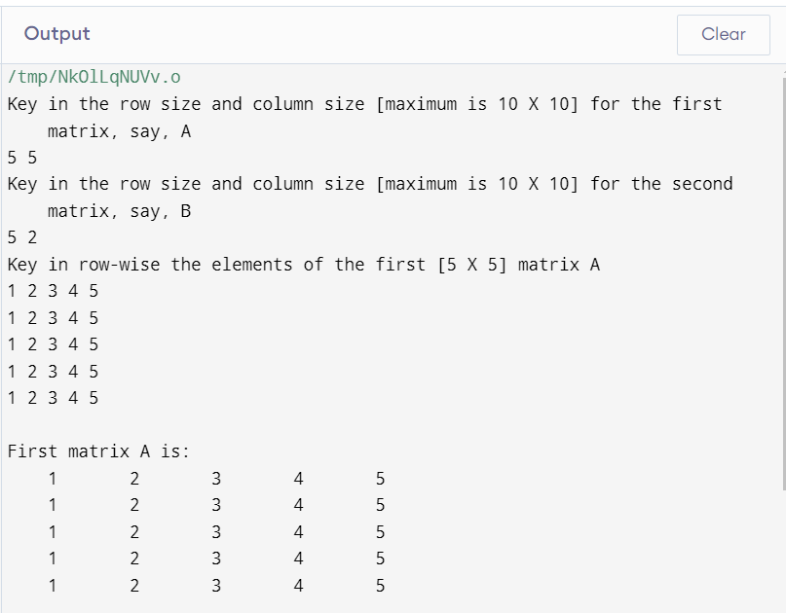

Q4) Left to Right Binary Exponentiation

#include <stdio.h>
#include <string.h>

int binaryexp(float base, int power) {
int binrev[100], bin[100], i, l, j, k, powers;
double result;
i++;
powers = power;
i = 0;

while (power) {
binrev[i] = power % 2;
power = power / 2;
i++;
l = i;
}
for (k = 0; k < l; k++, i--)
bin[k] = binrev[i - 1];
printf("\n binary is \n");
for (k = 0; k < l; k++)
printf("\t%d \t", bin[k]);
printf("\n");
result = 1;
for (j = 0; j < l; j++) {
if (bin[j] == 1)
result = result * result * base;
if (bin[j] == 0)
result = result * result;
}

printf("\n %f to the power %d using left to right binary exponentiation is \n\n\t%lf \n\n", base, powers, result);
}

void main() {
float x;
int n;
printf("\nKey in the base number X whose power is to be calculated using left to right binary exponentiation is required and the value of power / index \n\n");
scanf("%f%d", &x, &n);
printf("\n------X = %f............... power / index = %d\n", x, n);
binaryexp(x, n);
}

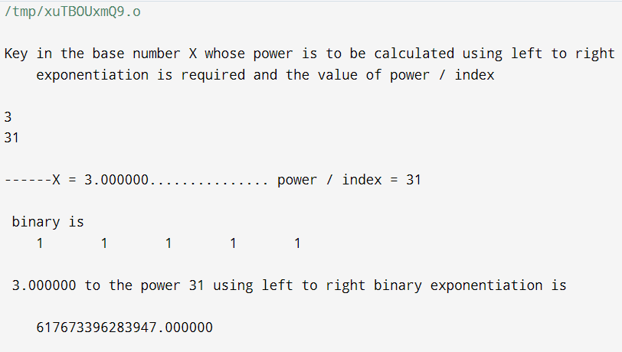

Q5) Bubble sort

#include <stdio.h>

void main() {
int A[10], i, j, n, t;
int cmpcount = 0, swapcount = 0, outerloopcount = 0, innerloopcount = 0, swapcheck = 0;

printf("Key in the count of elements to be sorted [Maximum 10] \n");
scanf("%d", &n);

printf("Key in the %d elements\n", n);
for (i = 0; i < n; i++) {
scanf("%d", &A[i]);
}

printf("\nThe keyed-in elements are:\n");
for (i = 0; i < n; i++) {
printf("%d\t", A[i]);
}
printf("\n");

for (i = 0; i < n - 1; i++) {
swapcheck = 0;
outerloopcount++;
for (j = 0; j < n - i - 1; j++) {
innerloopcount++;
cmpcount++;

if (A[j] > A[j + 1]) {
swapcheck = 1;
swapcount++;
t = A[j];
A[j] = A[j + 1];
A[j + 1] = t;
}
}
if (swapcheck == 0) {
break;
}
}

printf("\nThe sorted list is:\n");
for (i = 0; i < n; i++) {
printf("%d\t", A[i]);
}
printf("\n");

printf("\nThere were %d inner loop iterations, %d outer loop iterations, %d comparisons, and %d swaps\n\n",
innerloopcount, outerloopcount, cmpcount, swapcount);
}

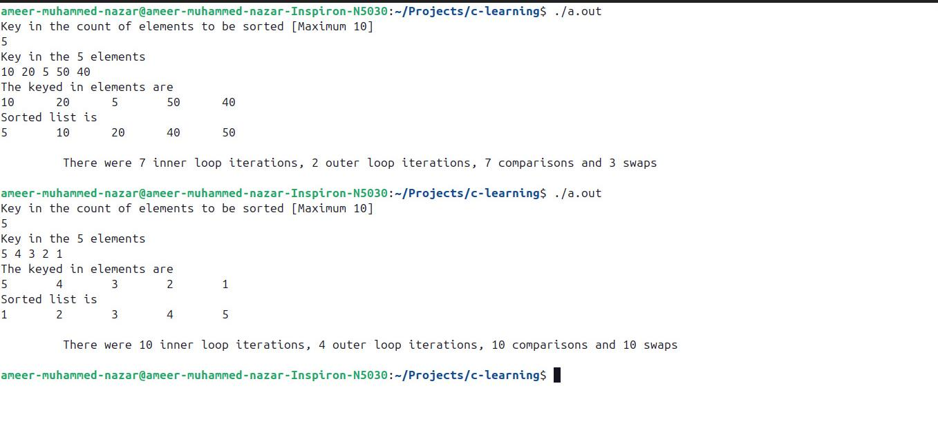

Q6) Selection Sort

#include <stdio.h>

void swap(int *f, int *s) {
int t = *f;
*f = *s;
*s = t;
}

int main() {
int A[10], i, j, n;
int cmpcount = 0, swapcount = 0, outerloopcount = 0, innerloopcount = 0, minpos;

printf("Key in the count of elements to be sorted (Maximum 10)\n");
scanf("%d", &n);

printf("Key in the %d elements\n", n);
for (i = 0; i < n; i++) {
scanf("%d", &A[i]);
}

printf("\nThe elements are:\n");
for (i = 0; i < n; i++) {
printf("%d\t", A[i]);
}
printf("\n");

for (i = 0; i < n - 1; i++) {
outerloopcount++;
minpos = i;
for (j = i + 1; j < n; j++) {
innerloopcount++;
cmpcount++;
if (A[j] < A[minpos]) {
minpos = j;
}
}
if (minpos != i) {
swapcount++;
swap(&A[minpos], &A[i]);
}
}

printf("\nThe sorted list is:\n");
for (i = 0; i < n; i++) {
printf("\t%d", A[i]);
}
printf("\n");

printf("\nThere were %d inner loop iterations, %d outer loop iterations, %d comparisons, and %d swaps\n\n",
innerloopcount, outerloopcount, cmpcount, swapcount);

return 0;
}

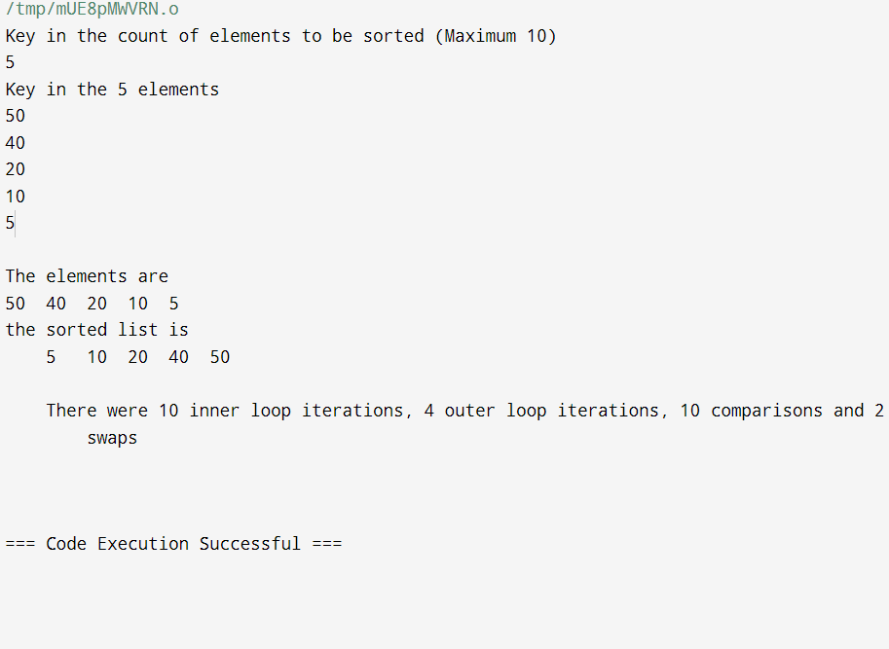

Q7) Fractional Knapsack problem

#include <stdio.h>

struct item {
int id;
int w;
int p;
float value;
};

void main() {
int i, j, w, p, tw = 0, capacity, itemcount;
float tv = 0, partp;

struct item K[50];

printf("\nKey in count of items [ maximum 50] and the maximum capacity of the bag\n\t");
scanf("%d%d", &itemcount, &capacity);

printf("Key in, row-wise [one line per item], the serial number, the weight and the profit for each of the %d items\n", itemcount);

for (i = 0; i < itemcount; i++)
scanf("%d%d%d", &K[i].id, &K[i].w, &K[i].p);

for (i = 0; i < itemcount; i++)
K[i].value = (float)K[i].p / K[i].w;

struct item KK;

for (i = 0; i < itemcount - 1; i++) {
for (j = 0; j < itemcount - 1 - i; j++) {
if (K[j + 1].value > K[j].value) {
KK = K[j + 1];
K[j + 1] = K[j];
K[j] = KK;
}
}
}

printf("The %d items arranged in non-descending order of the ratio Value = [ Profit/Weight ] is as under\n", itemcount);
printf("\n\tValue\tItem serial number\tWeight\tProfit\n");

for (i = 0; i < itemcount; i++)
printf("\n\t%0.2f \t\t %d \t\t %d \t %d \n", K[i].value, K[i].id, K[i].w, K[i].p);

printf("\n");
printf("The solution to the Fractional Knapsack problem\n\n");

for (i = 0; i < itemcount; i++) {
if (K[i].w + tw <= capacity) {
tw += K[i].w;
tv += K[i].p;

printf("\nSelected Item %d [whole]\t\tWeight %d \t Profit %d \t\tCumulative Weight\t%d\tCumulative Value \t%0.2f\n\n", K[i].id, K[i].w, K[i].p, tw, tv);
} else {
w = capacity - tw;
partp = (float)w * (float)K[i].p / (float)K[i].w;
tw += w;
tv += partp;
printf("\nSelected Item %d [part]\t\tWeight %d \t Profit %0.2f \t\tCumulative Weight\t%d\tCumulative Value \t%0.2f\n\n", K[i].id, w, partp, tw, tv);
break;
}
}

printf("\nThus the Knapsack with a capacity of %d can hold items worth a Cumulative Total Value of \t%0.2f\n\n", tw, tv);

printf("\n");
}

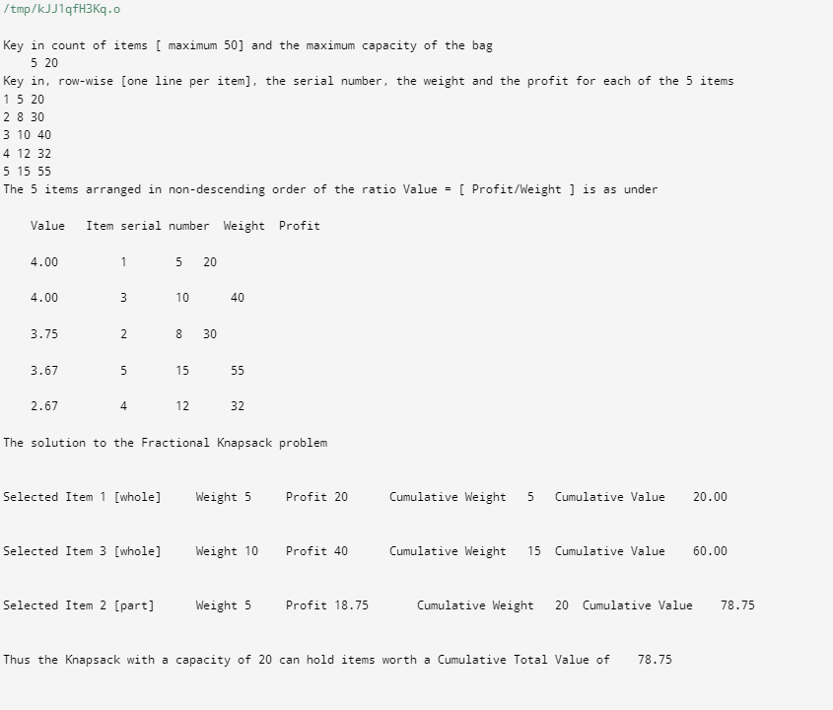

Q8) MST Prime algorithm

#include <stdio.h>
#include <stdlib.h>

#define MAX 10
#define TEMP 0
#define PERM 1
#define infinity 9999
#define NIL -1

struct edge
{
int u;
int v;
};

int n;
int adj[MAX][MAX];
int predecessor[MAX];
int status[MAX];
int length[MAX];

void create_graph();
void maketree(int r, struct edge tree[MAX]);
int min_temp();

int main()
{
int wt_tree = 0;
int i, root;
struct edge tree[MAX];
printf("\n\n vertices are numbered from 0 to end, say, 0, 1,2,...,9; key in edge in the format <start vertex> <SPACE> <end vertex>, say, without quotes \", \"0 19\". \n\n");
create_graph();
printf("\nKey in root vertex: ");
scanf("%d", &root);
maketree(root, tree);
printf("\nEdges to be included in spanning tree are: \n");

for (i = 1; i <= n-1; i++)
{
printf("%d->", tree[i].u);
printf("%d\n", tree[i].v);
wt_tree += adj[tree[i].u][tree[i].v];
}
printf("\nWeight of spanning tree is: %d\n", wt_tree);
return 0;
} /* End of main() */

void maketree(int r, struct edge tree[MAX])
{
int current, i;
int count = 0; /* Number of vertices in the tree*/
/* initialize all vertices */
for (i = 0; i < n; i++)
{
predecessor[i] = NIL;
length[i] = infinity;
status[i] = TEMP;
}
/* Make length of root vertex 0 */
length[r] = 0;
while (1)
{
/* search for temporary vertex with minimum length
and make it current vertex */
current = min_temp();
if (current == NIL)
{
if (count == n - 1) /* No temporary vertex left */
return;
else /* Temporary vertices left with length infinity */
{
printf("\nGraph is not connected, No spanning tree possible");
exit(1);
}
}
/* Make the current vertex permanent */
status[current] = PERM;

/* Insert the edge ( predecessor[current], current) into the tree
except when the current vertex is root */
if (current != r)
{
count++;
tree[count].u = predecessor[current];
tree[count].v = current;
}

for (i = 0; i < n; i++)
if (adj[current][i] > 0 && status[i] == TEMP)
if (adj[current][i] < length[i])
{
predecessor[i] = current;
length[i] = adj[current][i];
}
}
} /* End of make_tree */

/* Returns the temporary vertex with minimum value of length
Return NIL if no temporary vertex left or
all temporary vertices left have path length infinity*/
int min_temp()
{
int i;
int min = infinity;
int k = -1;
for (i = 0; i < n; i++)
{
if (status[i] == TEMP && length[i] < min)
{
min = length[i];
k = i;
}
}
return k;
} /* End of min_temp() */

void create_graph()
{
int i, max_edges, origin, destin, wt;
printf("\nKey in number of vertices: ");
scanf("%d", &n);
max_edges = n * (n - 1) / 2;
for (i = 1; i <= max_edges; i++)
{
printf("\nKey in edge %d(-1 -1 to quit) : ", i);
scanf("%d %d", &origin, &destin);
if ((origin == -1) && (destin == -1))
break;
printf("\nKey in weight for that edge: ");
scanf("%d", &wt);
if (origin >= n || destin >= n || origin < 0 || destin < 0)
{
printf("\nInvalid edge\n");
i--;
}
else
{
adj[origin][destin] = wt;
adj[destin][origin] = wt;
}
}
}

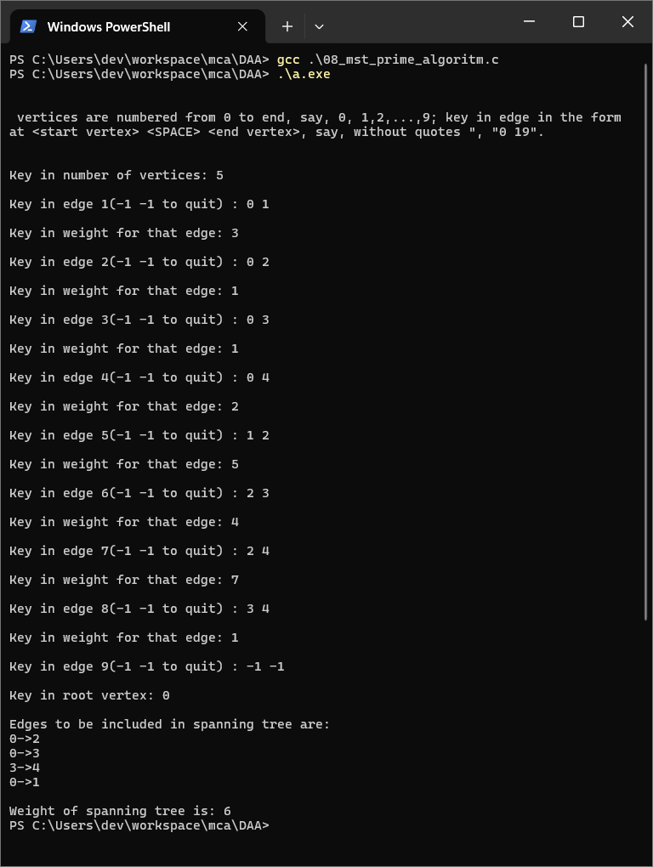

Q7) Fractional Knapsack problem

// Matrix Chain Multiplication and How to Place the Parentheses

#include <stdio.h>
#include <limits.h>
#define infinity 999999999
long int m[20][20];
int s[20][20];
int d[20], i, j, n;

void print_optimal(int i, int j)
{
if (i == j)
printf("A%d", i);
else
{
printf("(");
print_optimal(i, s[i][j]);
print_optimal(s[i][j] + 1, j);
printf(")");
}
}

void matmultiply(void)
{
long int q;
int k;
for (i = n; i > 0; i--)
{
for (j = i; j <= n; j++)
{
if (i == j)
m[i][j] = 0;
else
{
for (k = i; k < j; k++)
{
q = m[i][k] + m[k + 1][j] + d[i - 1] * d[k] * d[j];
if (q < m[i][j])
{
m[i][j] = q;
s[i][j] = k;
}
}
}
}
}
}
int MatrixChainOrder(int d[], int i, int j)
{
if (i == j)
return 0;
int k;
int min = INT_MAX;
int count;
for (k = i; k < j; k++)
{
count = MatrixChainOrder(d, i, k) +
MatrixChainOrder(d, k + 1, j) + d[i - 1] * d[k] * d[j];
if (count < min)
min = count;
}
// Return minimum count
return min;
}
void main()
{
int k;
printf("\nKey in the count of matrices\t");
scanf("%d", &n);
for (i = 1; i <= n; i++)
for (j = i + 1; j <= n; j++)
{
m[i][j] = 0;
m[i][j] = infinity;
s[i][j] = 0;
}
printf("\n\nKey in the dimensions\n");
for (k = 0; k <= n; k++)
{
printf("d%d:", k);
scanf("%d", &d[k]);
}
matmultiply();
printf("\nMinimum cost elements m[i][j] are\n");
for (i = 1; i <= n; i++)
{
printf("\n\n\t");
for (j = i; j <= n; j++)
printf("m[%d][%d]:%ld\t", i, j, m[i][j]);
}
// cost matrix

printf("\n\nMinimum cost diagonal matrix is\n");
for (i = 1; i <= n; i++)
{
printf("\n\n");
for (j = 1; j <= n; j++)
printf("\t%ld", m[i][j]);
}
printf("\n\n Minimum number of multiplications is : %d", MatrixChainOrder(d, 1, n));
printf("\n\n");
i = 1, j = n;
printf("\n Multiplication Sequence for the %d matrices is ", n);
print_optimal(i, j);
printf("\n\n");
}

